# CS 340 README Template

## About the Project/Project Title

*This project is working with an innovative internal rescue- animal training company. The data that is being used is from five different animal shelters in the region around Austin, Texas. Grazioso Salvare is looking for dogs that meet may meet the proper requirements for search and rescue. The purpose of this program is to help to be able to identify the dogs breed, and age to determine if they could be a candidate.*

## Motivation

*The motivation for this project is to be able to find the dogs that are able to meet the physical requirements that could possible be trained in search and rescue. Some of these requirements could be breed as certain breeds are better at different climates, elements than others. As well as dogs not even two years old are easy to train than a dog that is older and may not be able to handle the training. If the dog is able to pass certifications then these dogs will be able to save humans and other animals from life threatening conditions.*

## Getting Started

## Installation

*List the tools you need to use the software and how to install them.*

*The database that needs to be loaded within the mongo terminal is Austin Animal Center (AAC) – to import type in the following commands /usr/local/datasets/, mongoimport –port ##### --db AAC –collection animals –type=csv –headerline./aac_shelter-outcome.csv*

*The items that need to be imported in the python script is Mongo client from pymongo – this looks like from pymongo import MongoClient, and ObjectId from bson.objectId this looks like – from bson.objectid import ObjectId. And pprint which looks like – import pprint – this makes the data readable when testing it.*

*There are multiple tools to recreate this some can be done based on perference. For this project the terminal is being used as well as jupyter notebooks.*

*------------------------------------------------------------------------------------------------------------------------------------------*

*To get the application running you will need to implement the following commands: from jupyter_plotly_dash import JupyterDash, import dash, import dash_leaflet as dl, import dash_core_components as dcc, important dash_html_components as html, import plotly.express as px, import dash_table as dt, from dash.dependencies import Input, Output, State, important base64, import os, import numpy as np, import pandas as pd, from pymongo import MongoClient, from bson.json_util import dumps.*

*Be sure to call your CRUD module*

## Usage

*Use this space to show useful examples of how your project works and how it can be used. Be sure to include examples of your code, tests, and screenshots.*

### Code Example

*Show what the library does as concisely as possible. Developers should be able to figure out how your project solves their problem by looking at the code example. Make sure that your code is short and concise.*

*Within the data base a username and password was set. Within the python script I create a object within animal shelter to be able to call the username and password.*

*I then create objects to be able to create data or in a since insert a doucument with the information. See below for example of the code. I then created a read only to be able to read the data that is alredy in the system vs. what was just added. I then created a update method to be able to update different type of information based on a key. I also created a delete method to be able to delete data based on a certain key.*

*To get started the username and passward from the database will have to be hard set. In the program. I also implemented my CRUD file. As I imported that. I then added widgets, geographical location, a data table, and a html file. See below for the example of the code.*

### Tests

*Describe and show how to run the tests with code examples.*

*Test data:*

*Data + { “age_upon_outcome” : “1 year”, “animal_id” : “A625817”, “animal_type” : “Cat”, “breed” : “Domestic Shorthair Mix”, “color” : “Silver Tabby”, “date_of_birth” : “2015-05-02”, “datetime” : “2016-05-06 10:49:00”, “monthyear” : “2016-05-06T10:49:00”, “name” : “”, “outcome_subtype” : “SCRP”, “outcome_type” : “Transfer”, “sex_upon_outcome” : “Spayed Female”, :location_lat” : 30.6525984560228, “location_long” : -97.7419963476444, “age_upon_outcome_in_weeks” : 52.9215277777778.*

*Based on this data I then tested to see if the data was created.*

*I then tested to see if I could pull the data by a key to be able to read the information on the example.*

*For the application I would be search by the breed and then looking by the age upon the outcome to determine if this was the type of candidate that there were looking.*

### Screenshots

*Provide screenshots that demonstrate your work.*

Import Data Base

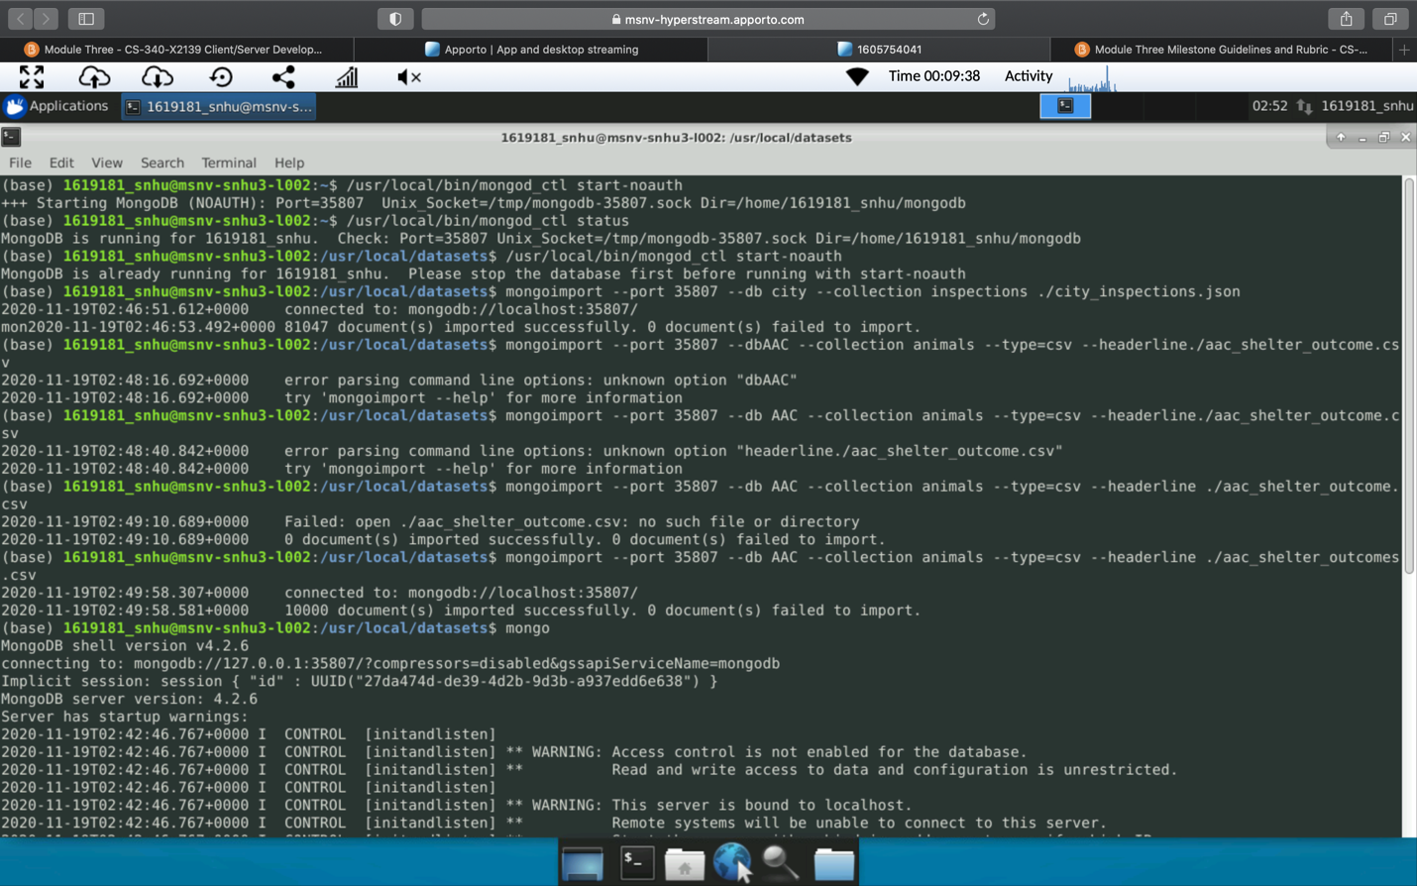

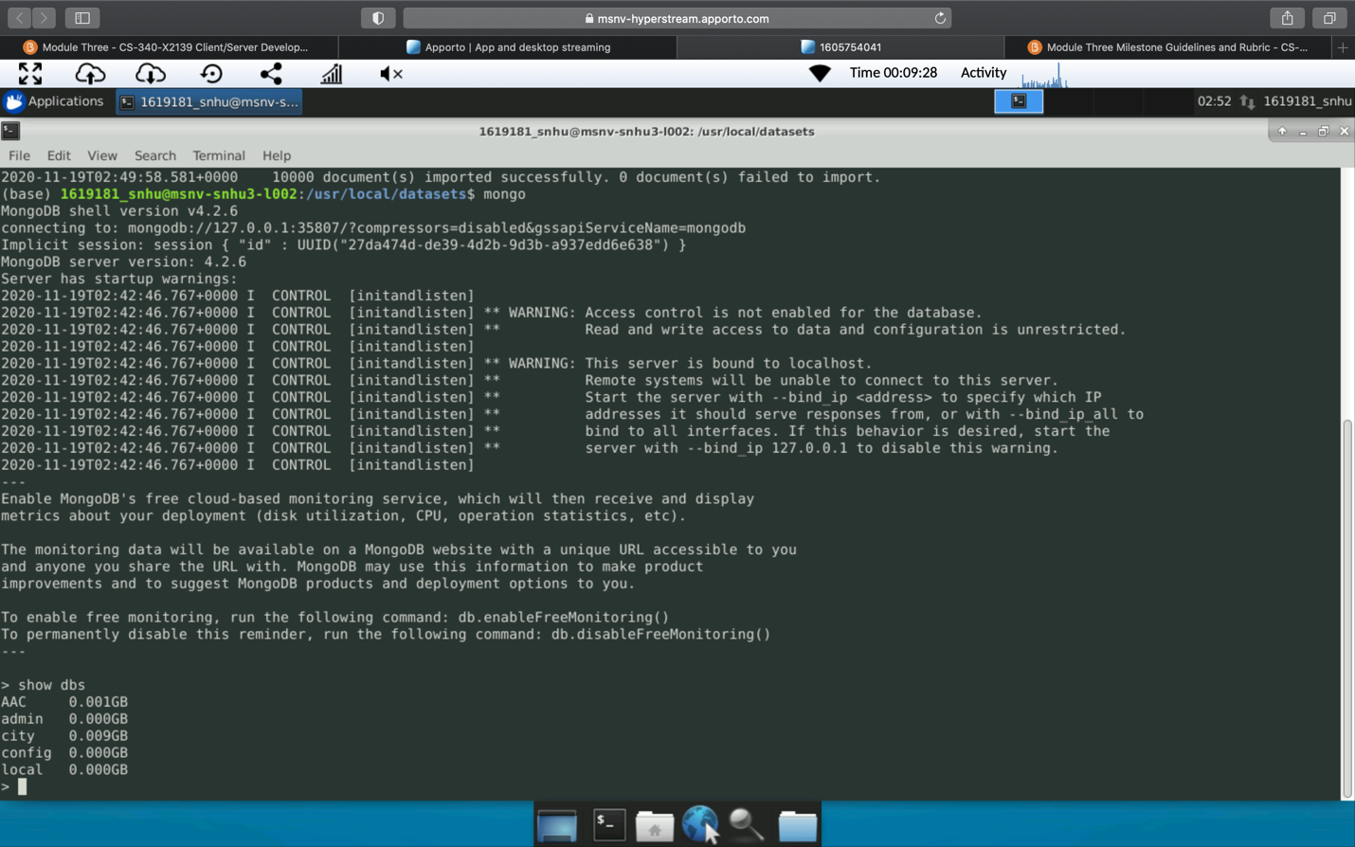

Create the C and R in the CRUD file

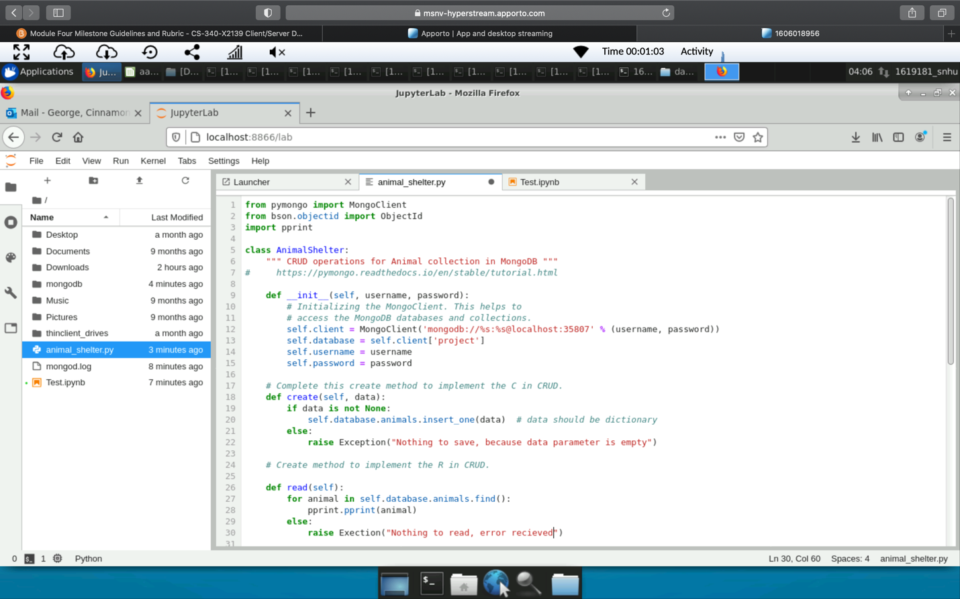

Create the U and D files in the CRUD File

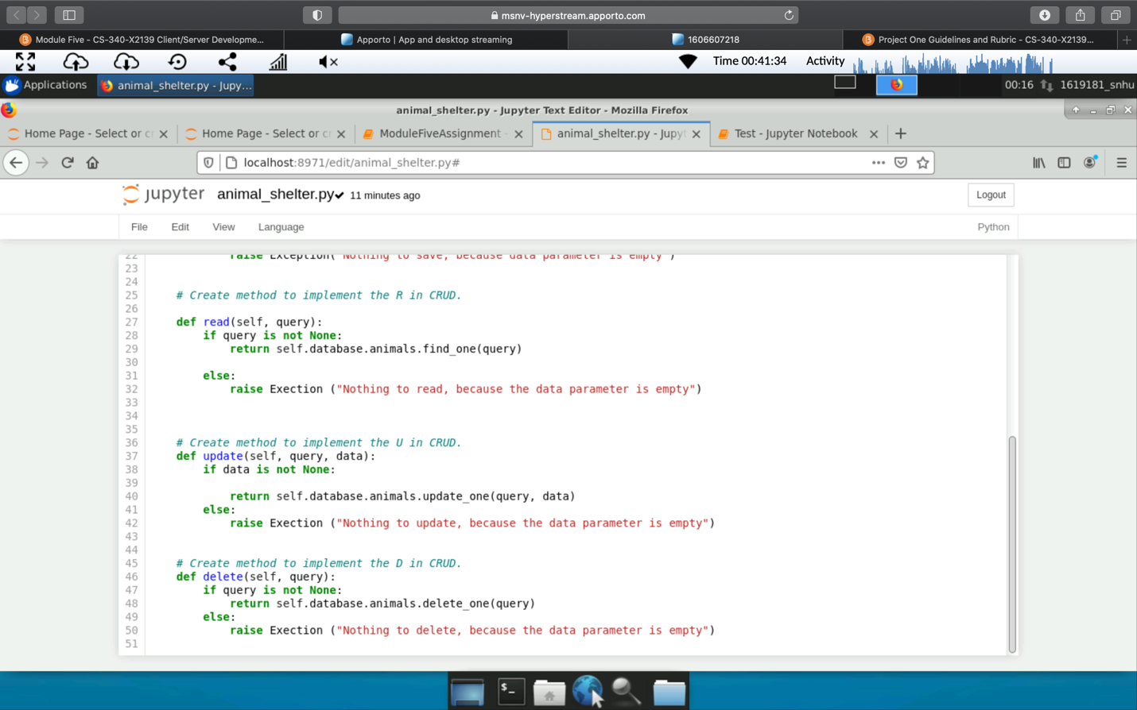

Test CRUD file

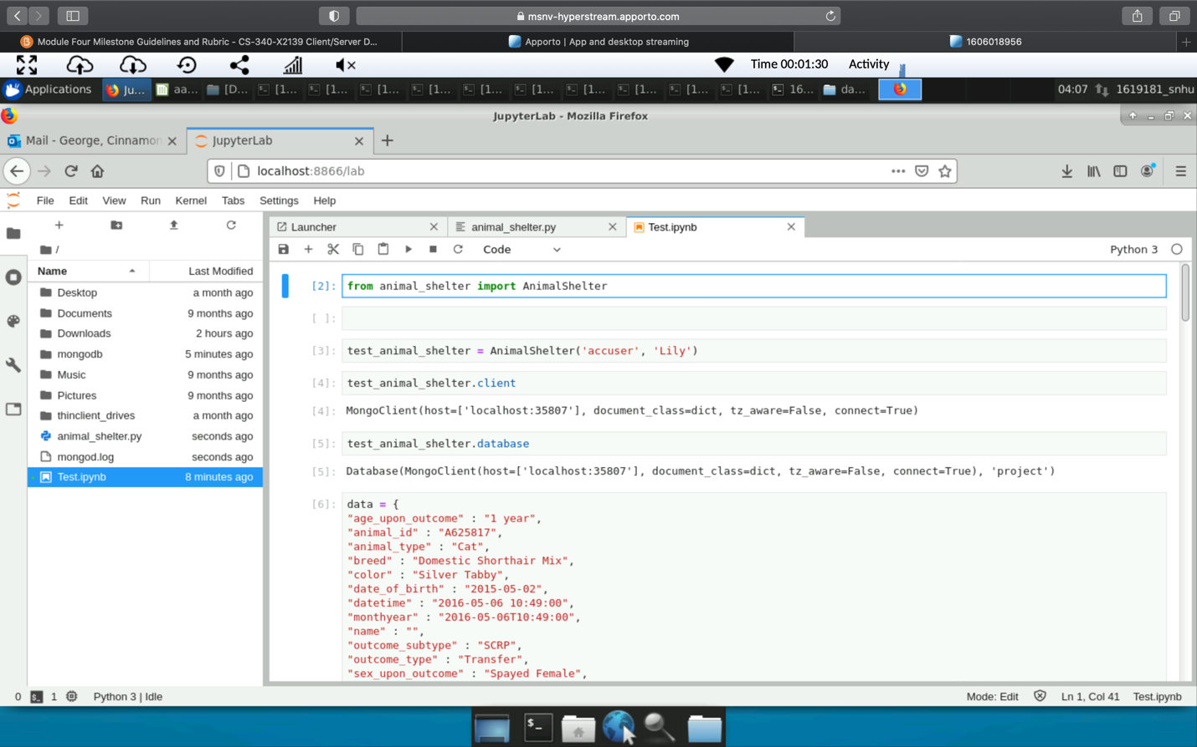

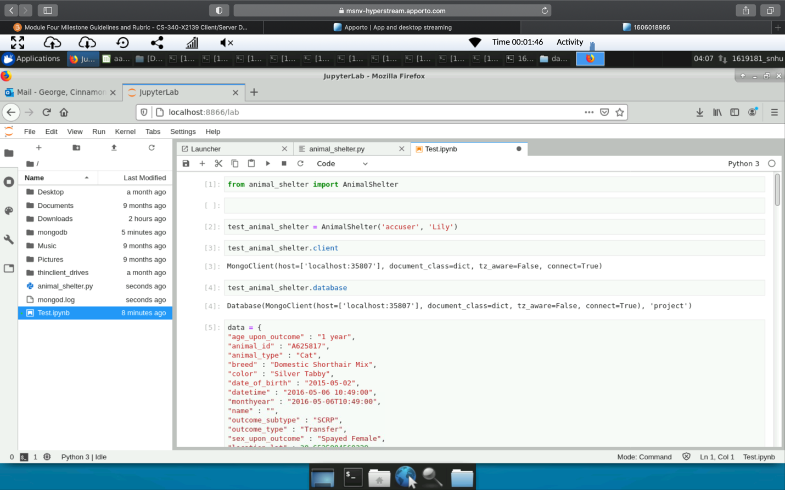

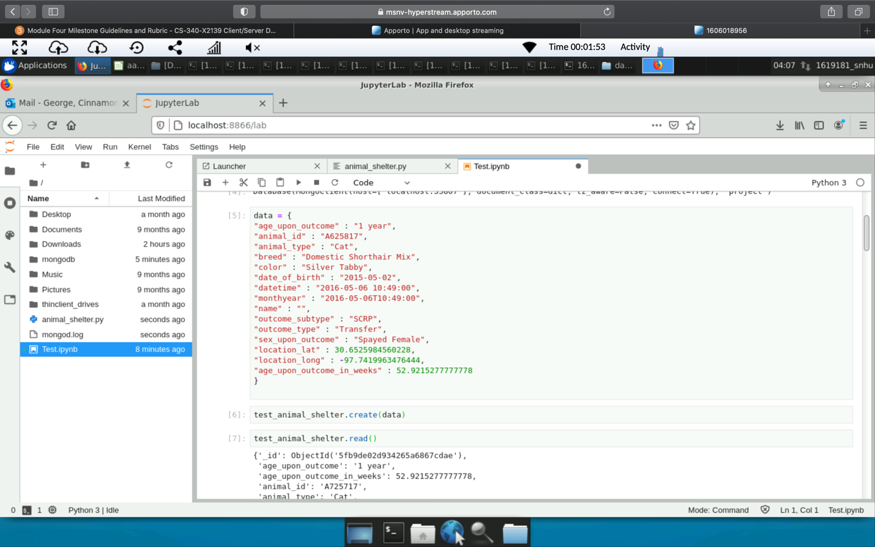

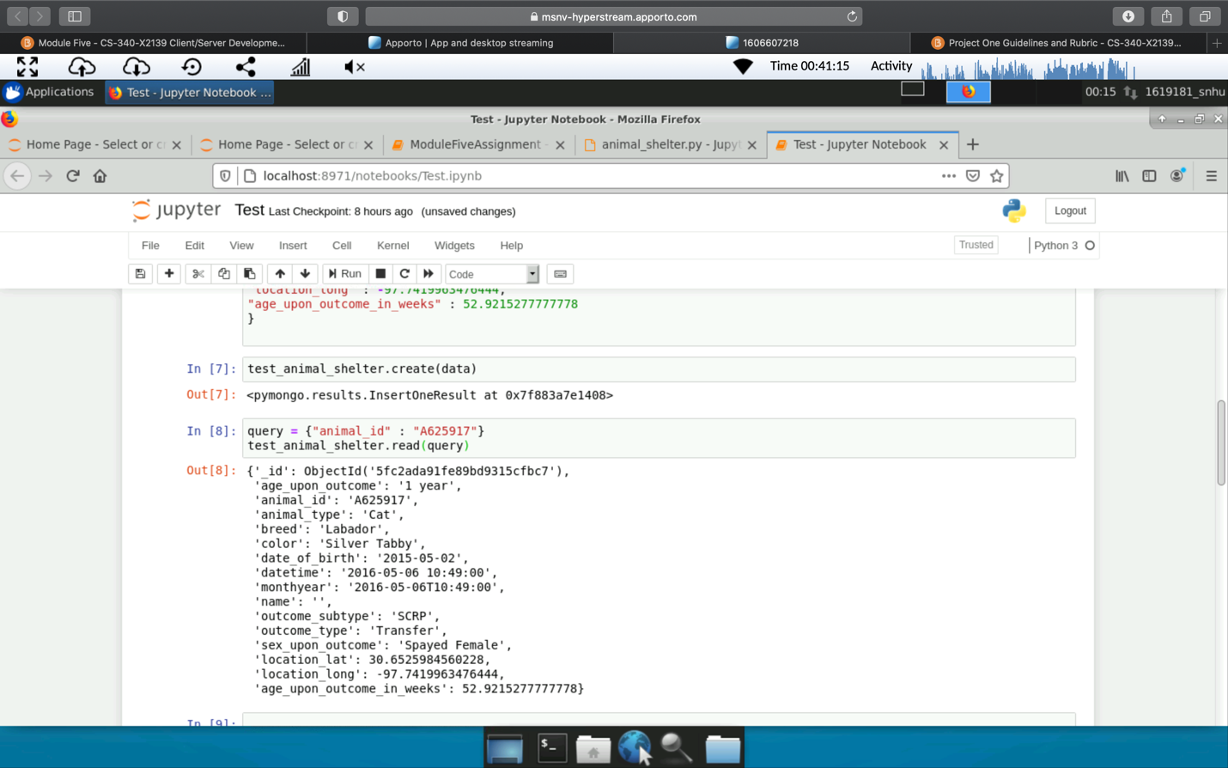

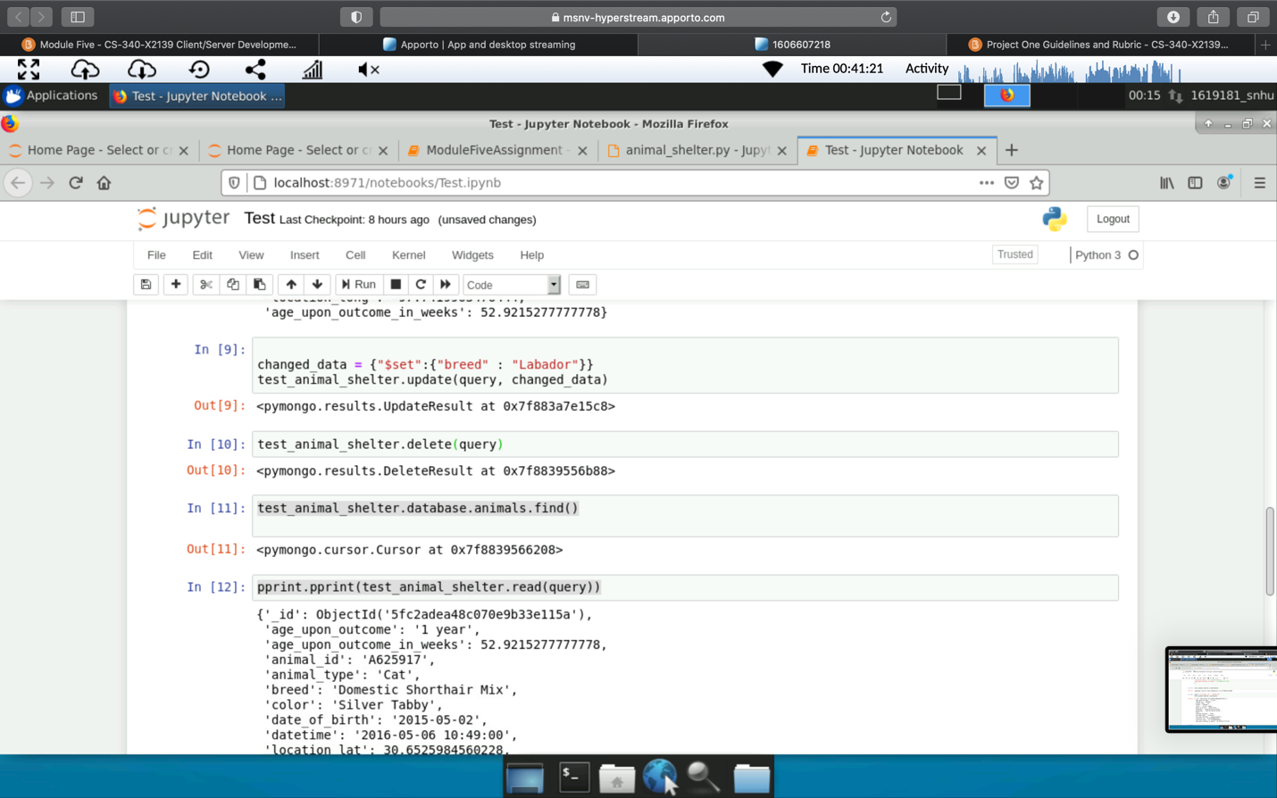

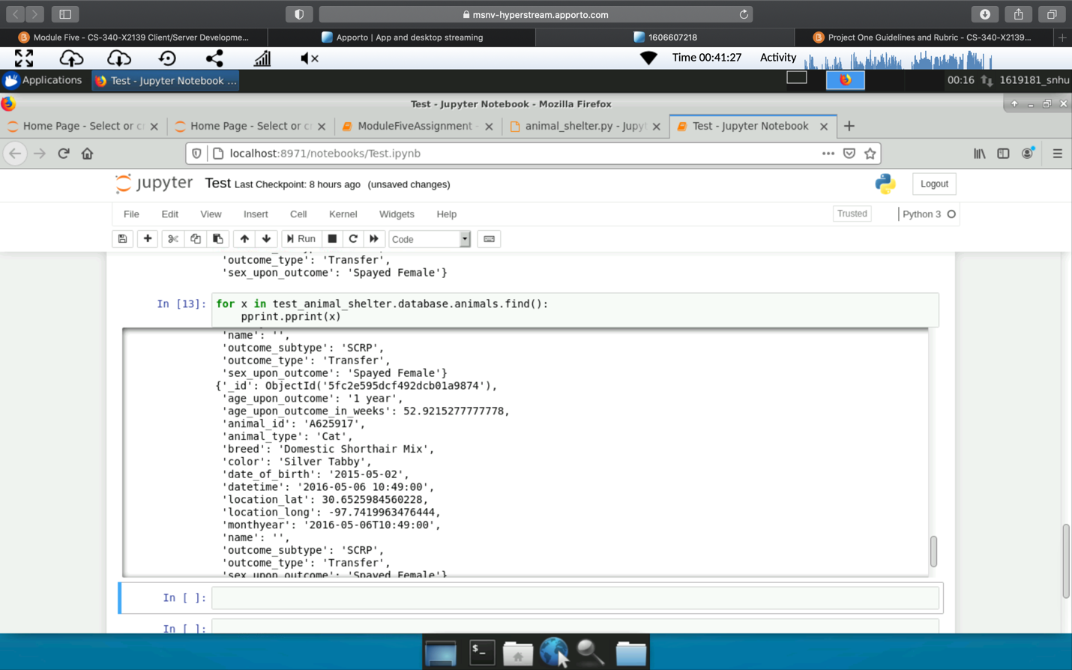

Test for breeds that are being looked for:

Water rescue

Mountain or Wildness rescue

Disaster or Individual tracking

Reset

*Import CRUD module*

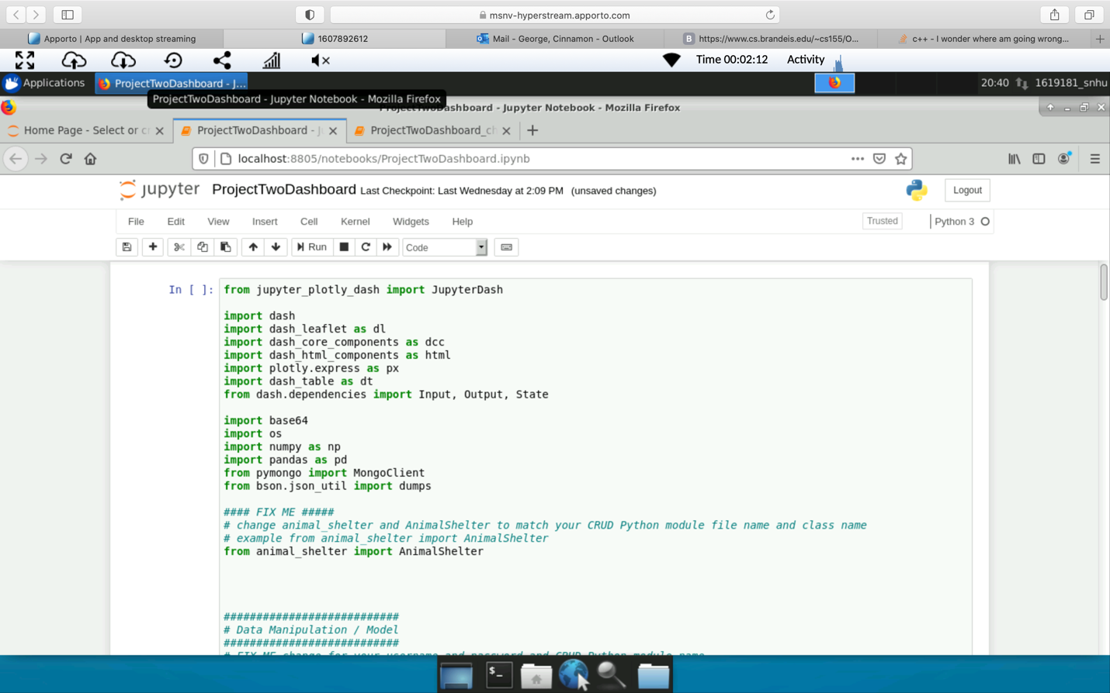

*Changes the username and password to fit the CRUD python module/ add Graziso logo, and read the data within the CRUD module*

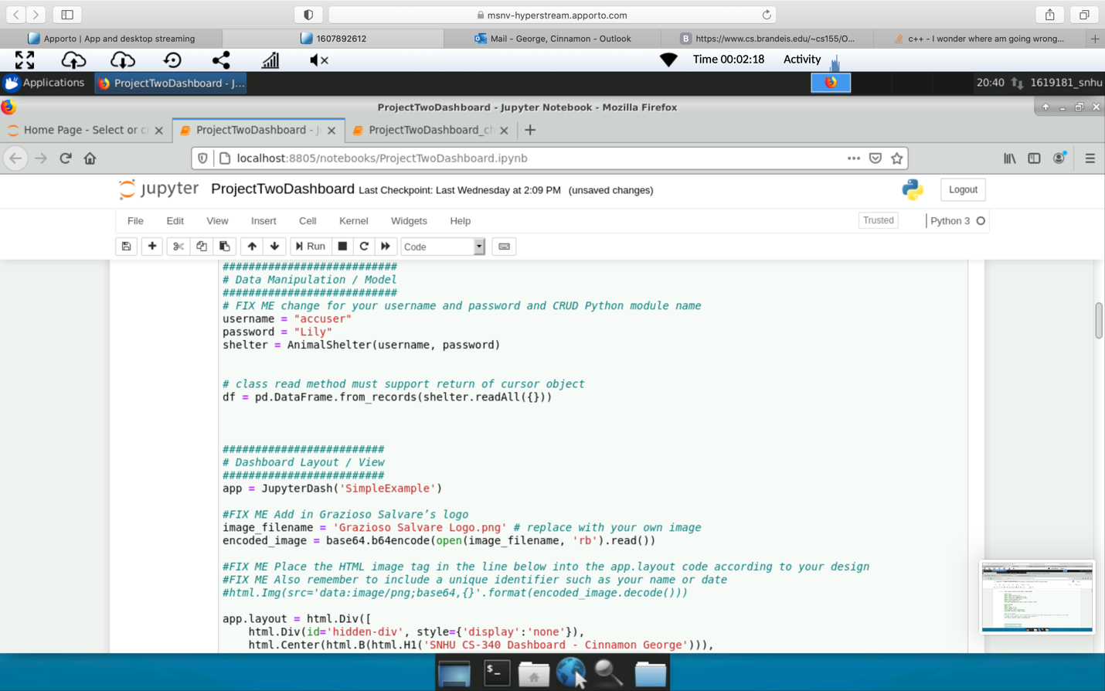

*Add the html and interactive filtering options*

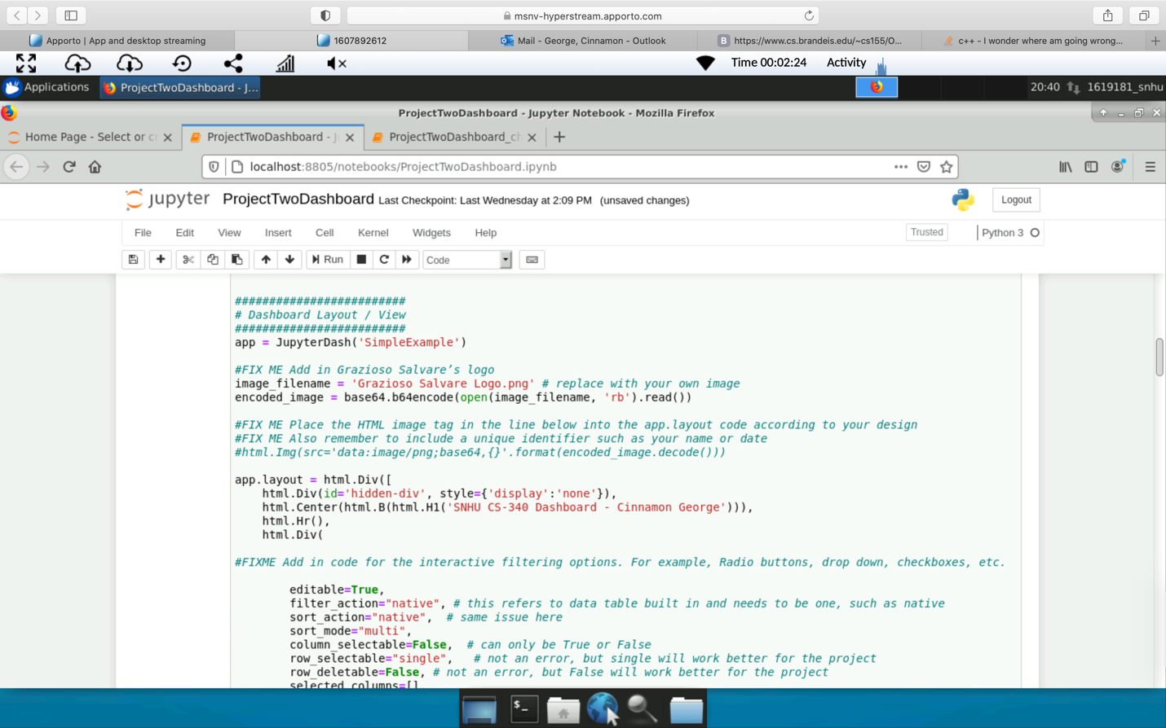

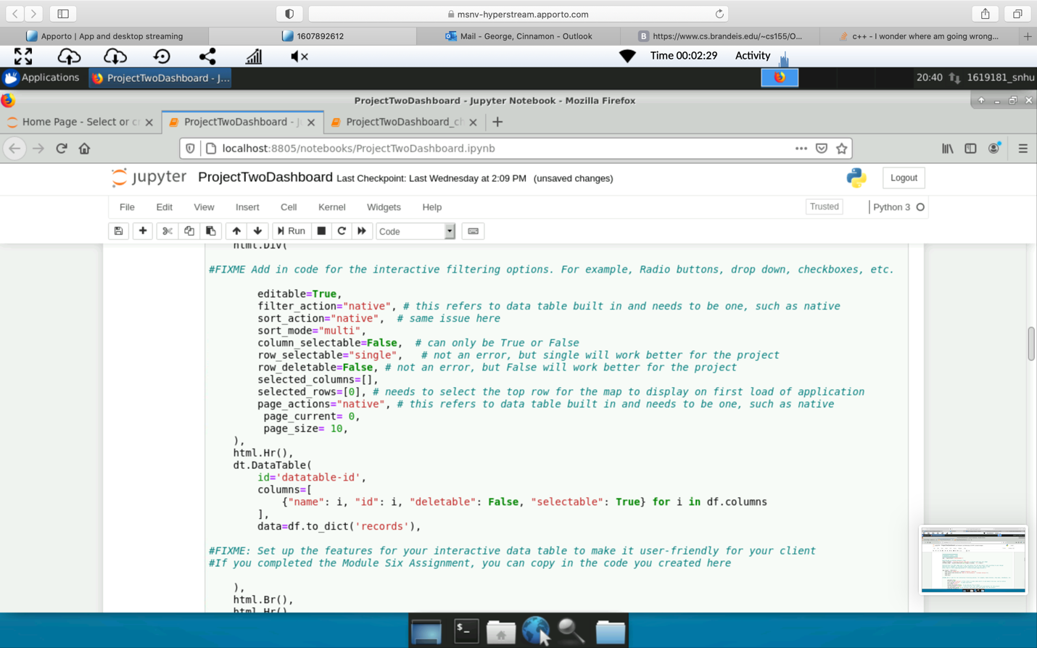

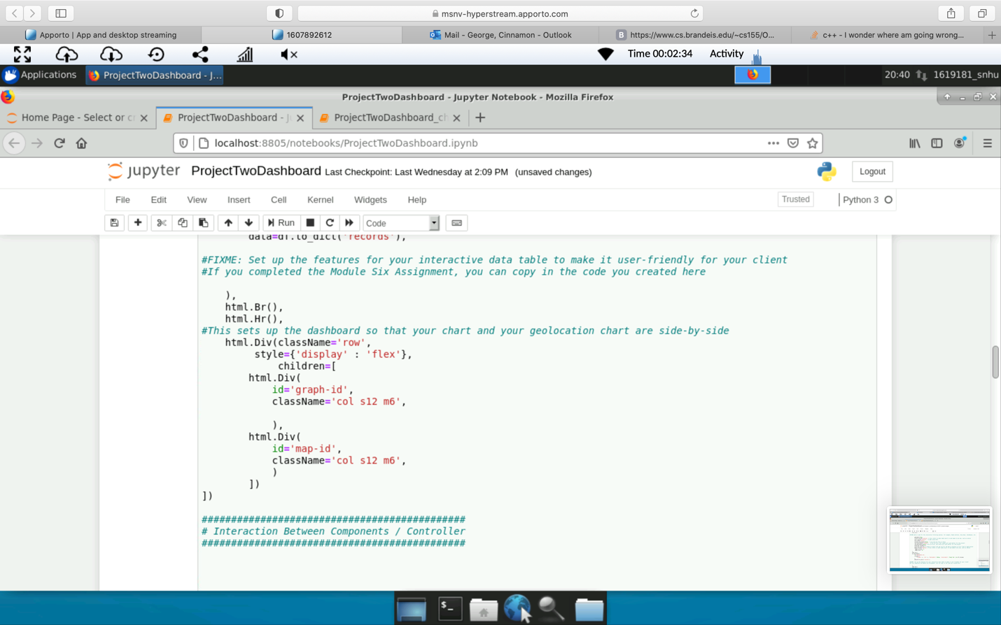

*Interaction between Componets / Controller*

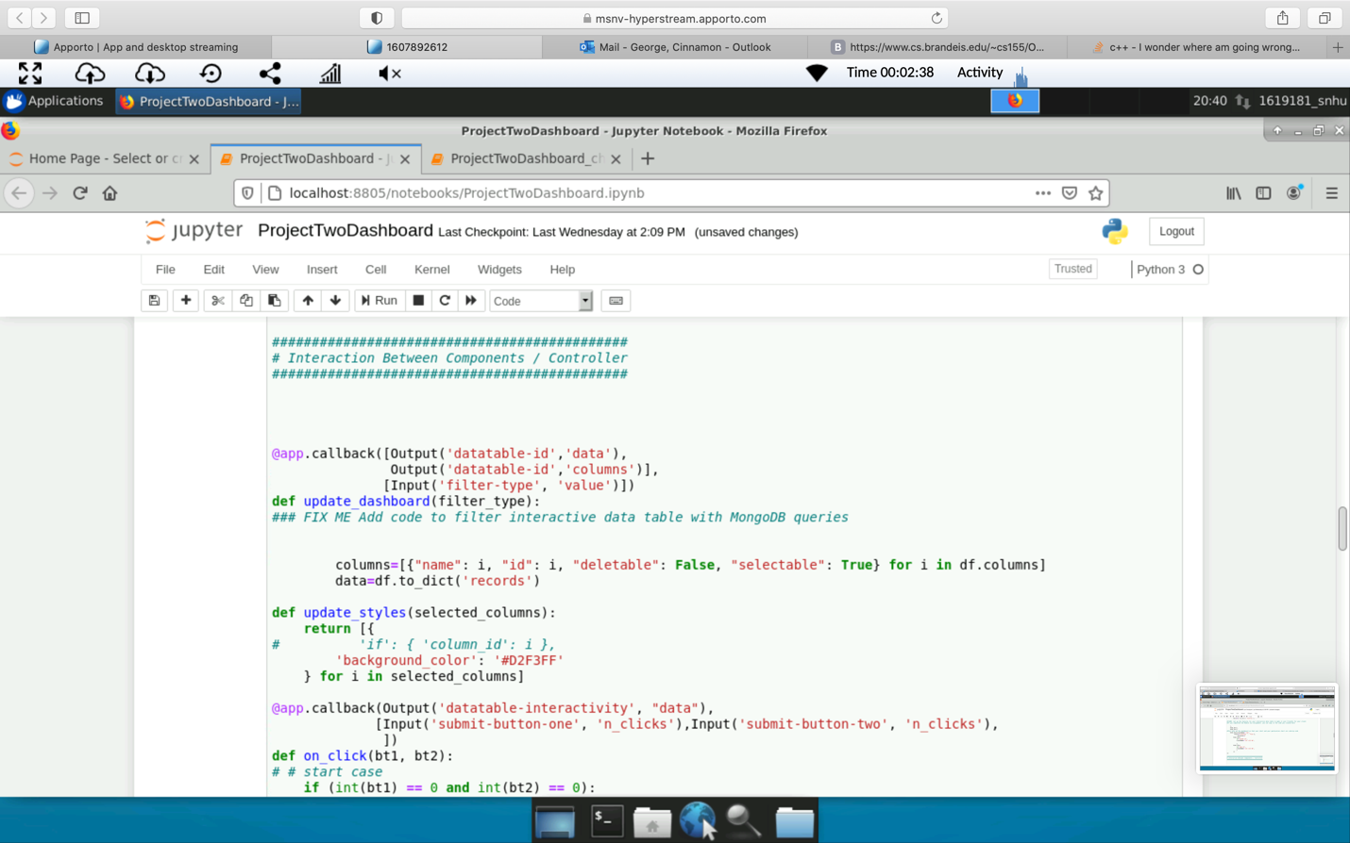

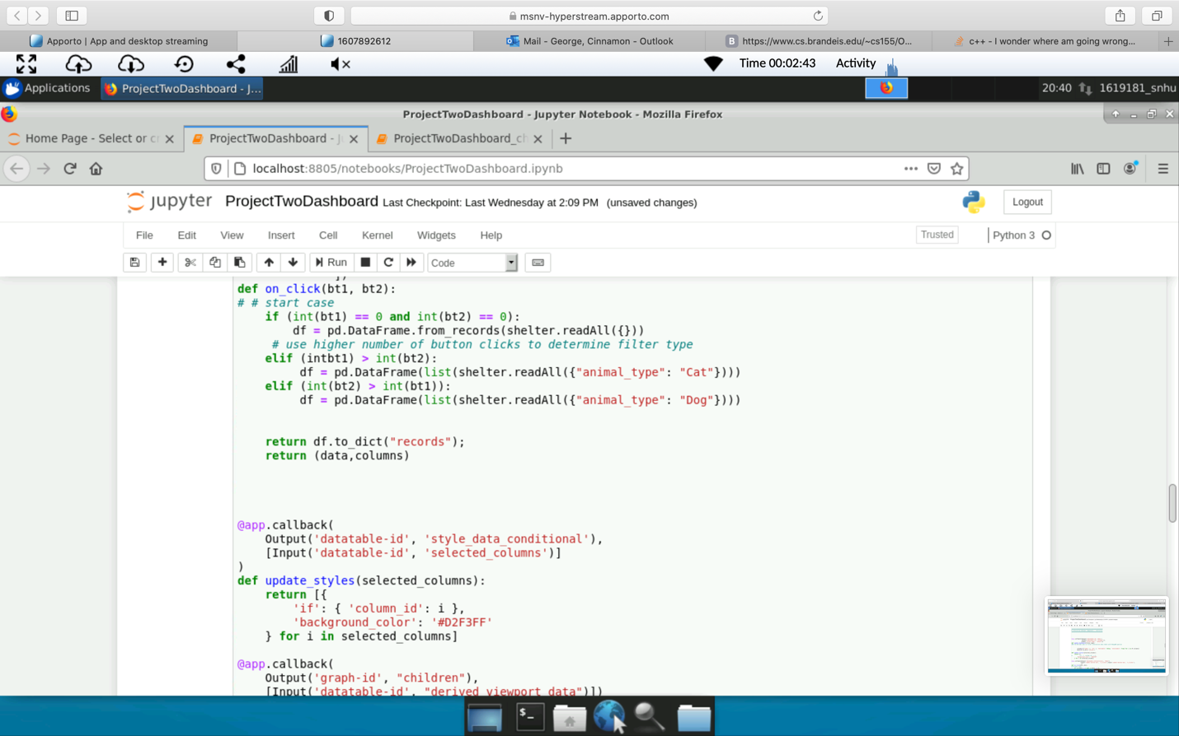

*Add Graph and Geographical Location*

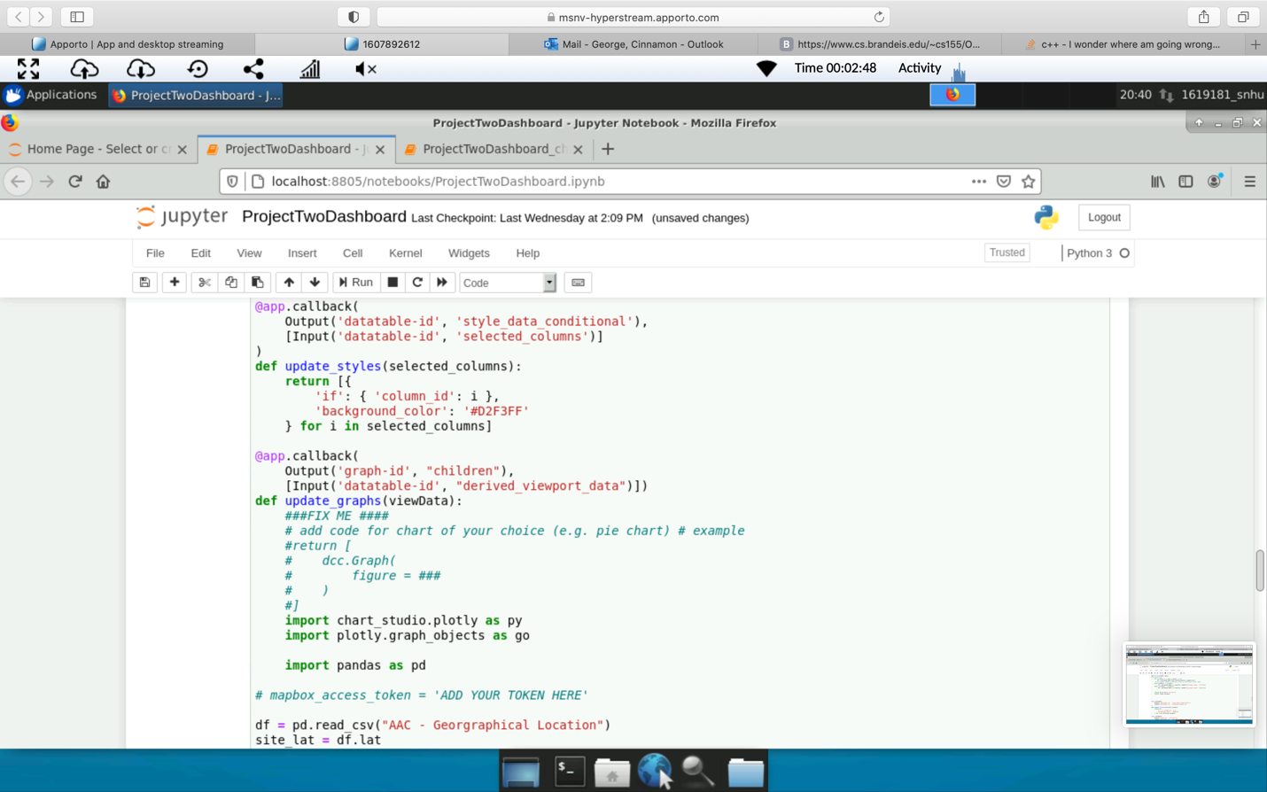

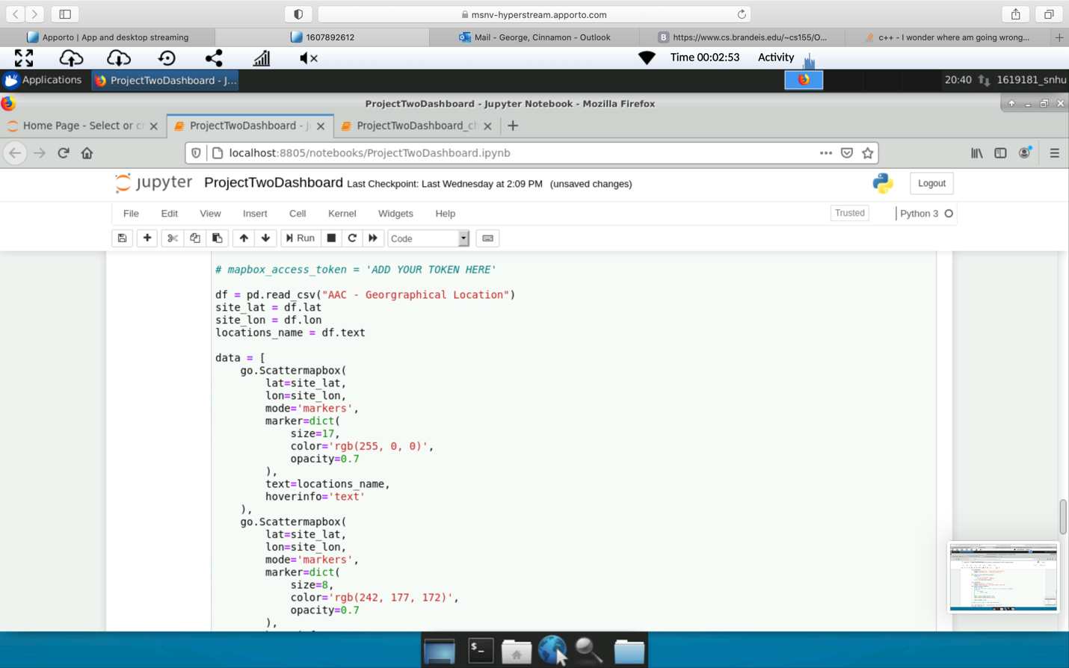

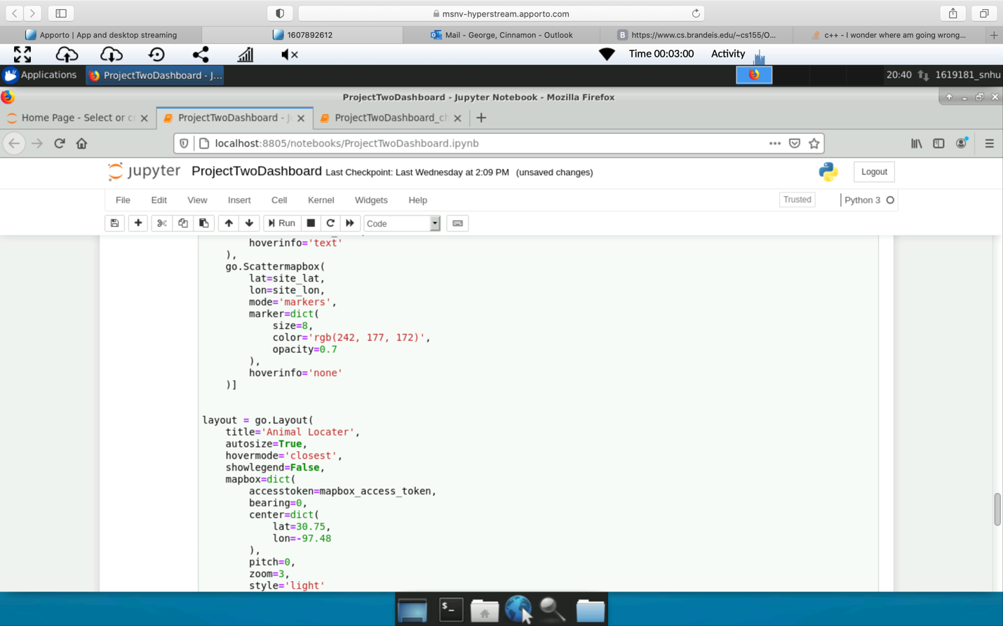

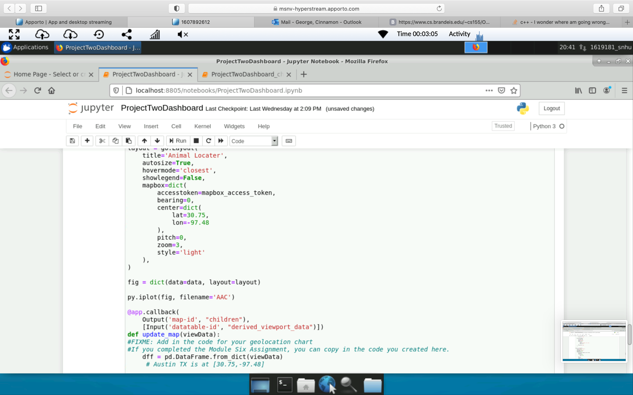

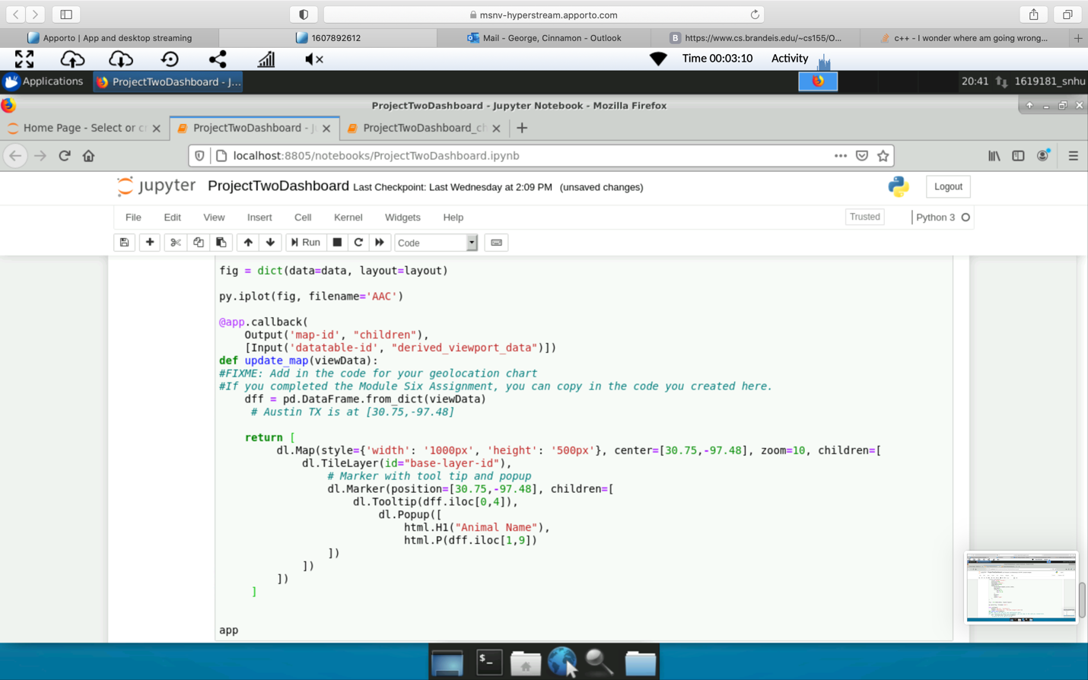

## Roadmap/Features (Optional)

*Provide an open issues list of proposed features (and known issues). If you have ideas for releases in the future, it is a good idea to list them in the README. What makes your project stand out?*

*In the feature this could expand to not only search and rescue but as well as other types of service dogs or animals. This could also expand into more regions and make it more global. In a way this could also help all the animals and prevent the shelters from filling up and some of those animals could have a purpose such as serach and resuce, k9s for the frontline etc.  
  
Note: This section is optional for the purposes of this assignment. If you choose not to fill out this section, remove it from your final README file.*

## Contact

Your name: Cinnamon George